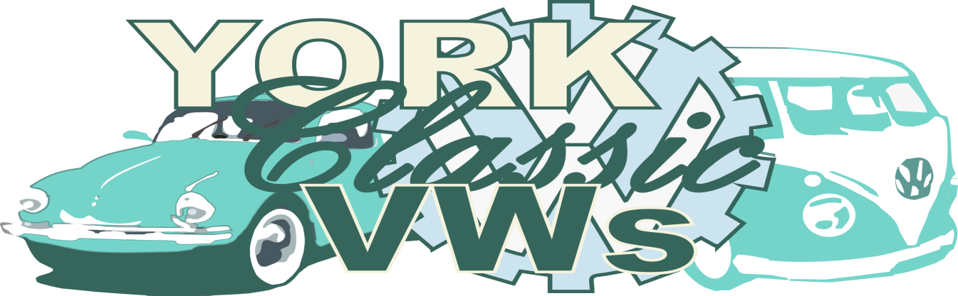

york classic vws owners club - Membership Application form

Applicant Information
Full Name 1:
Full Name 2:
Forum or Nick name:
Children (Under 16) Name(s):

Address:
 | Post Code:
Your Email:

membership fee
The membership fee is a one-time only payment of £10 per person or £20 per person if you would like a club t-shirt with your membership (these can be bought separately for the price of £12.50 some other time). Information on how to make payment is found in the section below.
This membership entitles the member(s) and their children aged sixteen or under to join in any club activities.
Note: Non-members are welcome to attend our meets - the more the merrier as far as that goes, our main focus here is to bring VW owners together however there will be occasions where ‘members only’ meetings or outings take place. We will be sure to make such occasions known to all members before hand.

how to pay for your membership – joining the club
DO NOT SEND CASH BY POST. Please email the completed application form to membership@yorkclassicvws.co.uk
Paying by Bank Transfer? Send an email to the email address above and we will send you our account details.
Paying by PayPal? PayPal payments can be made to yorkclassicvws@live.co.uk
Paying by Cheque or Postal Order? Send an email to membership@yorkclassicvws.co.uk and we will send you our mailing address.

club leader information
Name: Kate McCarthy Bedward
Facebook page: https://www.facebook.com/KateMcCarthyBedward
Address: YCVW, 39 ESCRICK HOUSE, FULFORD PLACE, YORK, YO10 4FE

additional information – volkswagen vehicle details
Make and Model:
Reg Number: | Engine Size: | Colour:
Year of Manufacture: | Name: | Post Code:

*membership t-shirt if required
Please put the number of T-shirts required next to the Size options listed. | S: | M:
 | L: | XL:

any other information you wish to tell us?

Signatures
I/We are applying to join the membership of the York Classic VWs Club and undertake to abide by the rules and regulations of the club. I/We are aware that membership details are held on computer and data is processed in accordance with the Data Protection Act 1998.

Signature of applicant 1: |  | Date:
Signature of applicant 2: |  | Date:

york classic vws owners club – club rules – terms of agreement
- As a Volkswagen Owners Club, members are expected to own a Volkswagen.

- Most members own a ‘Classic’ Aircooled Volkswagen as part of their main reason for joining but also own newer models. Our overall aim is to attract Classic Volkswagen enthusiasts.

- We reserve the right to cancel your membership should your behavior towards others (including members) particularly during Club activities (but not exclusively), negatively impacts the Clubs reputation and/or causes undue distress to other members.

